***Project Training Report***

***On­­­***

**Parking Space Counter**

**ABSTRACT**

The main aim of this project is to reduce the traffic in the parking place. Normally we can see in the multiplexes, cinema halls, large industries, and function halls there is problem they have to go and search which line is empty and which line having place to park the vehicle, for parking then they need workers for parking in correct position it is the money consumed process. So to avoid this problem Car Parking System project is implemented.

The parking space counter undertaken as a project is based on relevant technologies. This project has been developed to carry out the processes easily and quickly, which is not possible with the manuals systems, which are overcome by this software. This project is developed using OpenCv with Python.

The project analyzes the system requirements and then comes up with the requirements specifications. It studies other related systems and then come up with system specifications. The system is then designed in accordance with specifications to satisfy the requirements.

Parking Space Counter find how many total cars are present and how many spaces are vacant to park. In this project, we will be using basic Image Processing techniques to solve this problem

**TABLE OF CONTENT**

|  |  |  |
| --- | --- | --- |
| Sr no. | Topic | Page No. |
| 1 | Use of Modern tools in design and analysis |  |
| 2 | Discussion and report/results analysis |  |
| 3 | Project management and Professional communication (Presentation) |  |
| 4 | Attainment of stated outcomes |  |

**Use of Modern tools in design and analysis**

The Modern Tools used in this Project for Design and Analysis is Python. It is a Programming Language. It is used for web development (server-side), software development, mathematics, system scripting and many more.

Why Python ?

* Python works on different platforms (Windows, Mac, Linux, Raspberry Pi, etc).
* Python has a simple syntax similar to the English language.
* Python has syntax that allows developers to write programs with fewer lines than some other programming languages.
* Python runs on an interpreter system, meaning that code can be executed as soon as it is written. This means that prototyping can be very quick.
* Python can be treated in a procedural way, an object-oriented way or a functional way.
* There are Some Libraries Used Here in this Project:

**OpenCV :**

OpenCV is an open-source library for the computer vision. It provides the facility to the machine to recognize the faces or objects. In this tutorial we will learn the concept of OpenCV using the Python programming language.

There are two common ways to identify the images:

**1. Grayscale**

Grayscale images are those images which contain only two colors black and white. The contrast measurement of intensity is black treated as the weakest intensity, and white as the strongest intensity. When we use the grayscale image, the computer assigns each pixel value based on its level of darkness.

**2. RGB**

An RGB is a combination of the red, green, blue color which together makes a new color. The computer retrieves that value from each pixel and puts the results in an array to be interpreted.

Here , In this Project , We are Using GreyScale Technique to identify whether the Space if empty or filled by using pixel approach.

**Numpy:**

NumPy is a Python library used for working with arrays. It also has functions for working in domain of linear algebra, fourier transform, and matrices.

NumPy was created in 2005 by Travis Oliphant. It is an open source project and you can use it freely.

NumPy stands for Numerical Python.

**Pickle:**

Python pickle module is used for serializing and de-serializing python object structures. The process to converts any kind of python objects (list, dict, etc.) into byte streams (0s and 1s) is called pickling or serialization or flattening or marshalling. We can converts the byte stream (generated through pickling) back into python objects by a process called as unpickling.

Why Pickle?: In real world sceanario, the use pickling and unpickling are widespread as they allow us to easily transfer data from one server/system to another and then store it in a file or database.

**CVZone:**

Cvzone is the library that develops a bridge between Arduino and python. With the help of the SerialObject module in Cvzone we can connect the arduino port with python as well as send data to arduino and can link any python code with it

**Discussion and report/results analysis**

Parking is one of the major problems that is created by the increasing road traffic. It is an impact of transport development. The availability of less space in urban areas has increased the demand for parking space especially in areas like Central business district. This affects the mode choice also. This has a great economical impact.

On street parking means the vehicles are parked on the sides of the street itself. This will be usually controlled by government agencies itself. Common types of on-street parking are as listed below. This classification is based on the angle in which the vehicles are parked with respect to the road alignment. As per IRC the standard dimensions of a car is taken as 5× 2.5 meters and that for a truck is 3.75× 7.5 meters.

Parking has some ill-effects like congestion, accidents, pollution, obstruction to fire-fighting operations etc.

**Congestion:** Parking takes considerable street space leading to the lowering of the road capacity. Hence, speed will be reduced, journey time and delay will also subsequently increase. The operational cost of the vehicle increases leading to great economical loss to the community.

**Accidents:** Careless maneuvering of parking and unparking leads to accidents which are referred to as parking accidents. Common type of parking accidents occur while driving out a car from the parking area, careless opening of the doors of parked cars, and while bringing in the vehicle to the parking lot for parking.

**Environmental pollution**: They also cause pollution to the environment because stopping and starting of vehicles while parking and unparking results in noise and fumes. They also affect the aesthetic beauty of the buildings because cars parked at every available space creates a feeling that building rises from a plinth of cars.

**Obstruction to fire fighting operations:** Parked vehicles may obstruct the movement of firefighting vehicles. Sometimes they block access to hydrants and access to buildings.

**Parking surveys**

Parking surveys are conducted to collect the above said parking statistics. The most common parking surveys conducted are in-out survey, fixed period sampling and license plate method of survey.

**In-out survey**

In this survey, the occupancy count in the selected parking lot is taken at the beginning. Then the number of vehicles that enter the parking lot for a particular time interval is counted. The number of vehicles that leave the parking lot is also taken. The final occupancy in the parking lot is also taken. Here the labor required is very less. Only one person may be enough. But we wont get any data regarding the time duration for which a particular vehicle used that parking lot. Parking duration and turn over is not obtained. Hence we cannot estimate the parking fare from this survey. For quick survey purposes, a fixed period sampling can also be done. This is almost similar to in-out survey. All vehicles are counted at the beginning of the survey. Then after a fixed time interval that may vary between 15 minutes to i hour, the count is again taken. Here there are chances of missing the number of vehicles that were parked for a short duration.

### C:\Users\vishnupriya\PycharmProjects\Parking Space Counter Project\web11x.png

|  |
| --- |
|  |

**Project management and Professional communication**

**(Presentation)**

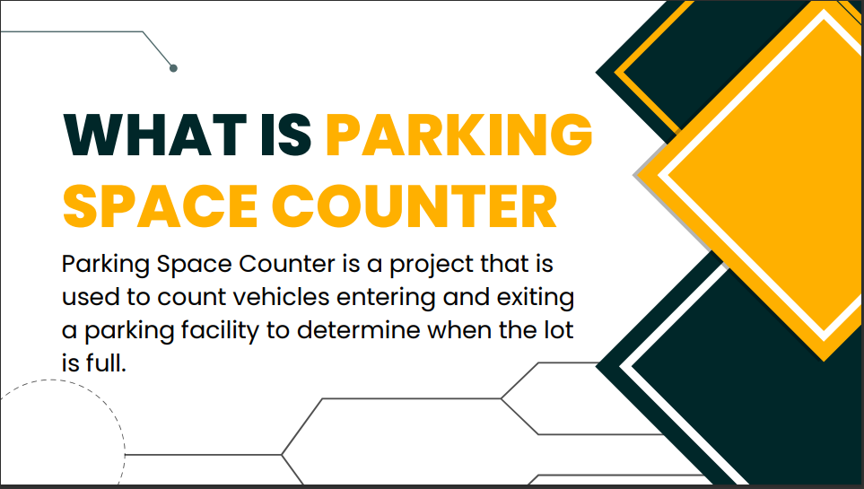

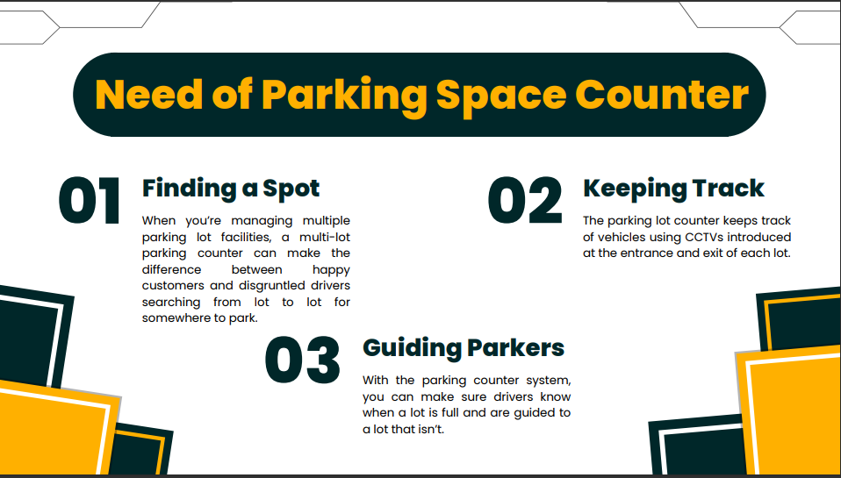

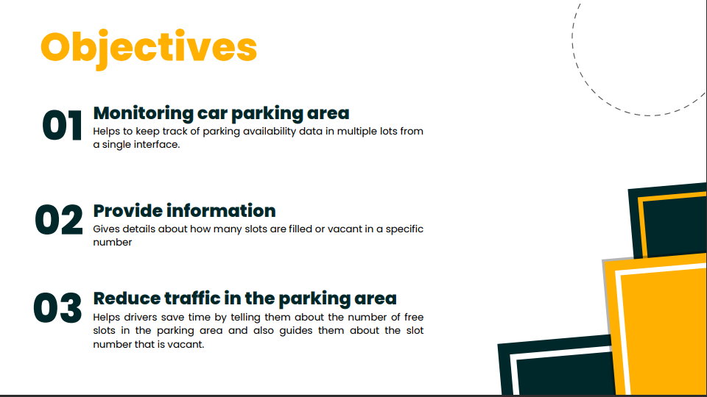

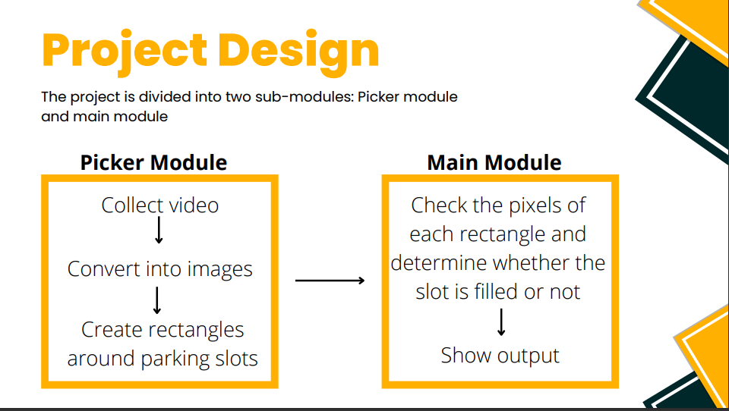

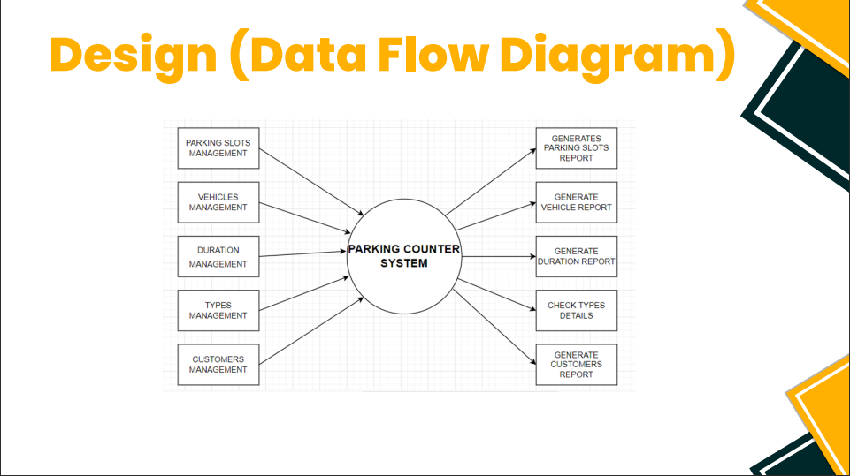

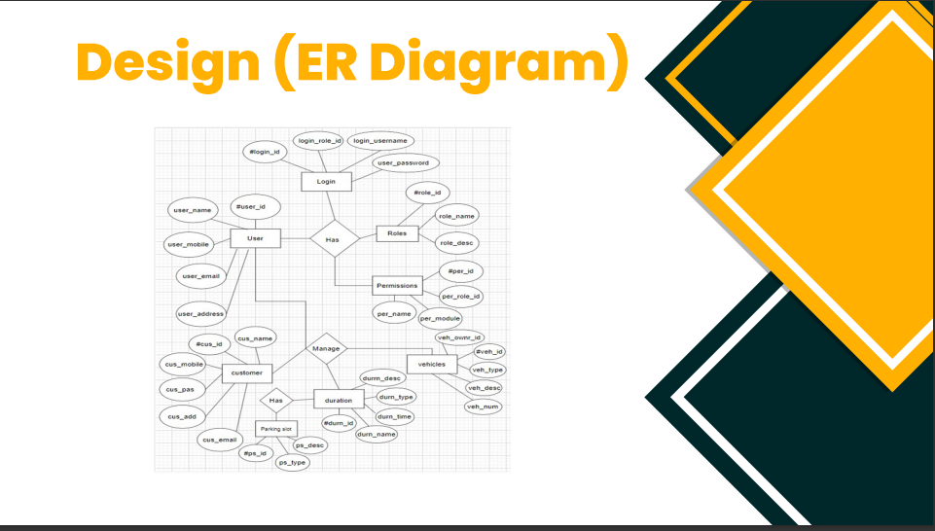

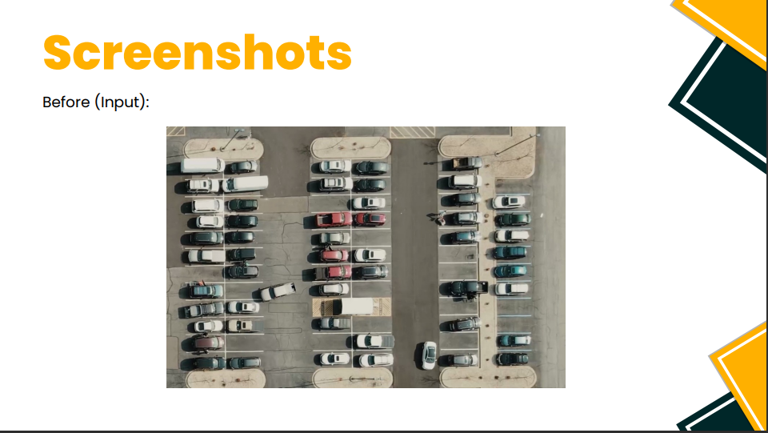

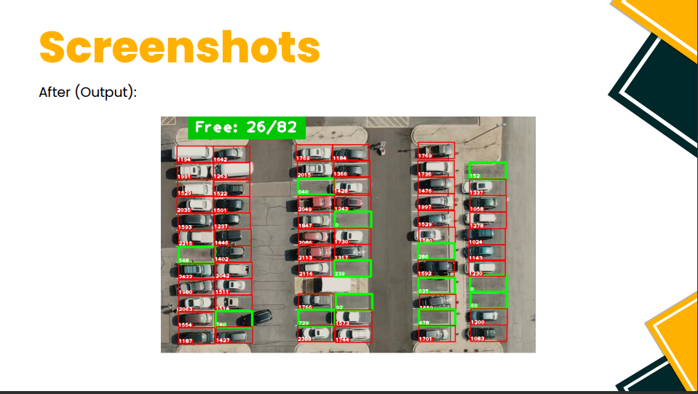

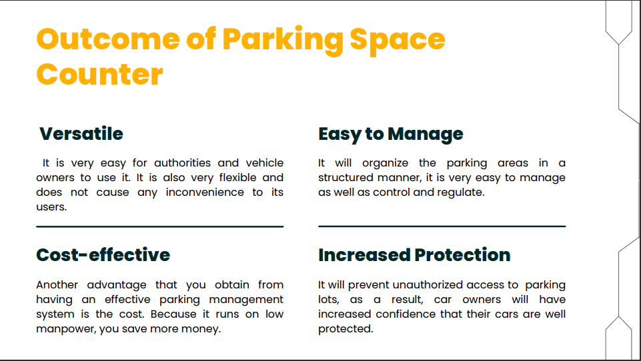

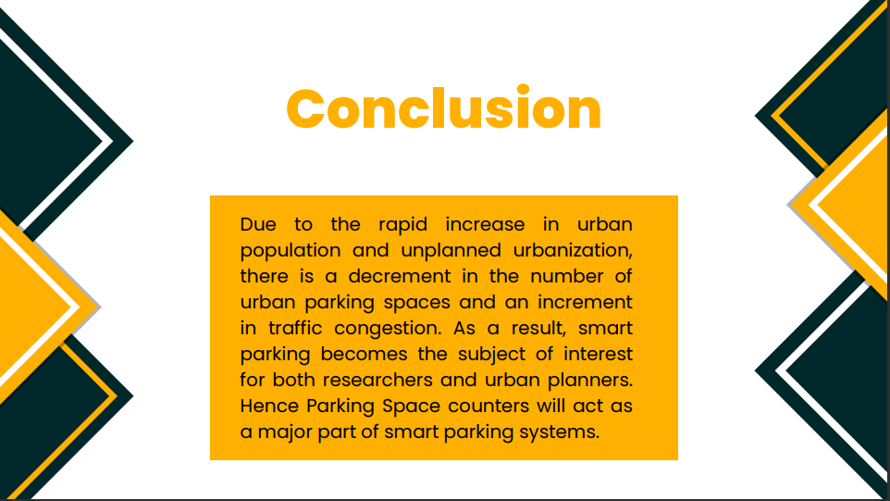



**Attainment of stated outcomes**

The main aim of this project is to reduce the traffic in the parking place. Normally we can see in the multiplexes, cinema halls, large industries, and function halls there is problem they have to go and search which line is empty and which line having place to park the vehicle, for parking then they need workers for parking in correct position it is the money consumed process. So to avoid this problem Car Parking System project is implemented.

Counting Available Parking Space using Image Processing is prototype system that detecting the existence of parked vehicles by processing the image of a parking lot taken by surveillance camera. After that, system will count how many available parking lot spaces each division and display it in front of entrance parking lot.

Image Processing defines as analysis of a picture using techniques that can identify shades, colors and relationships that cannot be perceived by the human eye. 8 Image processing is used to solve identification problems, such as in forensic medicine or in creating weather maps form satellite pictures. It deals with images in bitmapped graphics format that have been scanned in or captured with digital cameras. Image Processing also defines as any image improvement, such as refining a picture in a paint program that has been scanned or entered from a video source.

Nowadays, drivers always face difficulty of finding available parking lot while entering into a huge parking area. A Car-Park Occupancy Information System is developed to be a viable solution to reduce the amount of time needed to search for a vacant car-park lot especially in a huge parking area. With this system, images captured by a surveillance camera were processed in real-time to identify the occupancies of the parking lots. This occupancy information is further processed by a central control unit and distributed to display panels located at strategic locations at the parking area. The drivers can easily find a vacant parking lot based on the information displayed on the panels. Motivation for developing this system came from the fact that minimum cost is involved because image processing technique is used rather than sensor-based techniques. As surveillance cameras are readily available in most car parks, this technique is much cost effective than installing sensor on each parking lot. Locating Vehicle in a Parking Lot by image Processing is more concern to propose a method of detecting the existence of parked vehicles by processing the 10 image of a parking lot taken by a surveillance camera. Whenever driver wants to park a car at a parking lot, how to find a proper parking division there causes a serious problem. The objective of the present article is in providing drivers with such information as the lot is fully occupied or relatively vacant, where unoccupied parking divisions are found, and so on. The images employed, since all areas in the parking lot can be observed with relatively few cameras, the system is compact, and the cost is not expensive. The image of a parking lot is taken by a surveillance camera set at some height in the parking lot.